Ex 7
Aim
To design multiple mobile app layouts with different colour schemes using GIMP and
evaluate user feedback based on aesthetics and usability.
Procedure
1. 1. Design Creation
Created a mobile UI layout using GIMP with a canvas size of 1080 × 1920 pixels. Designed
header, content, and footer sections using tools like Rectangle Select, Bucket Fill, Text Tool,
and Shape Tools.
2. 2. Layout Variations
Generated multiple layout variations by duplicating the base design and applying different
colour schemes using GIMP tools. Saved outputs as Layout1, Layout2, and Layout3.
3. 3. User Feedback Collection
Shared the layouts with users via Google Forms and collected feedback based on visual
appeal, usability, readability, and colour preference.
4. 4. Analysis & Iteration
Analyzed user feedback and identified strengths and improvements for each layout. Refined
the design based on suggestions and usability considerations.
Google link
https://docs.google.com/forms/d/e/1FAIpQLSdfAViMVySGZMkDQ3tGs
JGo4QwcUIZLXrN3Mq84RY4xGy6cdg/viewform?usp=publish-editor

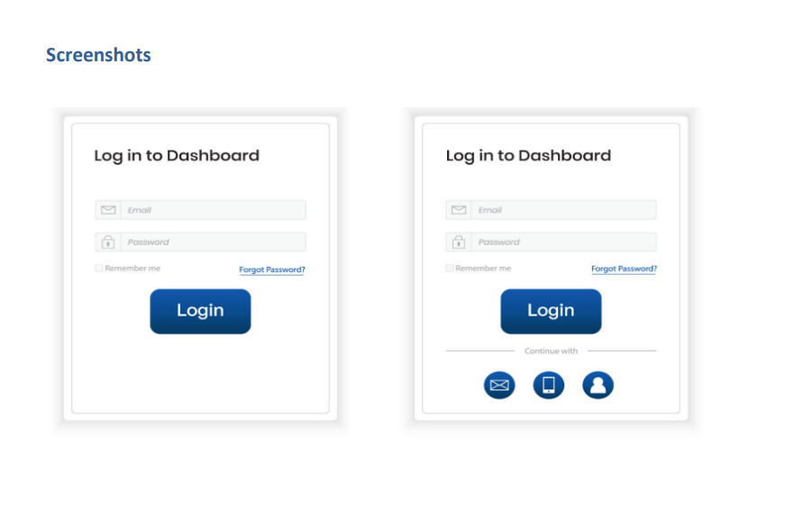

Results:
The experiment successfully identified the most user-preferred layout. Layout 3 was selected as the best design due to its clean, minimal, and professional appearance, along with better usability and balanced colour scheme.

